THE ROLE OF ENDOTHELIUM AND ENDOTHELIUM-DERIVED RELAXATION FACTORS IN NITRIC OXIDE-INDUCED AORTIC RELAXATION

Abbas B. Qadir Salihi¹and Omar A.M. Al-Habib²
¹Biology Dept., College of Science, University of Salahaddin, Erbil, Kurdistan, Iraq.
²Biology Dept., Faculty of Science, University of Zakho, Duhok, Kurdistan, Iraq.
(Accepted for publication: June 9, 2013)

ABSTRACT
The endothelium plays a key role in the control of vascular patency and tone. Thus, the main objective of the study was to determine the role of endothelium and its derived relaxation factors in mediating relaxation of rat thoracic aorta, in response to nitric oxide (NO) donor “sodium nitroprusside (SNP)” using PowerLab tissue bath system. Endothelial denudation enhanced relaxation responses of SNP(1X10⁻⁸ to 3X10⁻⁵ M)with IC₅₀ of5.872X10⁻⁸ as compared to control rings with IC₅₀’s of 2.266X10⁻⁶M, as well as the maximum relaxation (E_{max}) for both groups were 106.2±4.95% and 83.13±14.755%, respectively. The relaxation responses to SNP in aortic rings were significantly increased by Indomethacin and Clotrimazole pretreatment with IC₅₀’s of 1.72X10⁻⁷ M and 3.314 X10⁻⁸M, and E_{max} were increased to 121.5±5% and 121.1±8.09%, respectively. Whilst, no changes were observed in aortic rings pretreated with L-nitroargininemethylester (L-NAME) and methylene blue. The results of the current study had shown that endothelium denudation and blocking of endothelium derived-relaxation factors enhanced vasodilator effect of NO; this may be account for the role of endothelium in the vasodilatory effects of NO.

Keywords: Nitric Oxide, Endothelium denudation, Endothelium derived-relaxation factors, Organ bath, PowerLab system, Aorta.

INTRODUCTION
T
he vascular endothelium is strategically located at the interface between the circulating blood and vessel wall, exists in vivo as a monolayer of cells coupled to one another by gap and tight junctions, providing a permeability barrier to the movement of cell metabolites and nutrients, while allowing the transfer of electrical signals within the intact tissue (Adams and Hill, 2004). The endothelium performs not only a barrier function but also serves as a biomechanical sensor that maintains vascular integrity. Blood flow through a vessel creates fluid shear stress from the friction of blood against the vessel wall. This force, which acts in parallel to the vessel surface, activates the endothelium (Ying and Sanders, 2002).
Maintenance of vascular tone and blood flow by the endothelium is complex, involving many substances and an interplay among numerous cellular mechanisms (Panza, 1997). Endothelial cells synthesize and release various factors that modulate in short terms vascular tone, in long terms atherosclerosis, angiogenesis and inflammation. The vasoactive factors include relaxing substances, prostaglandin I₂ (PGI₂), NO, endothelium-derived hyperpolarizing factors (EDHF), C-natriuretic peptide, and contracting substances, such as, thromboxane A₂ (TXA₂), endothelin-1, angiotensin II, superoxide anion (Zhang, 2007).
Nitric oxide is a signaling mediator with diverse as well as opposing biological activities. The complexity of the NO response reflects the variety of its chemical reactions and biological properties. Steady-state NO concentration is a key determinant of its biological outcome as precise cellular responses are differentially regulated by specific NO concentrations (Ignarro, 2010). At high concentrations, NO readily reacts with oxygen, especially with superoxide, forming highly reactive, cytotoxic substances, such as peroxynitrite. At lower concentrations, NO serves regulatory roles via activation of soluble guanylatecyclase (sGC), resulting in increased cGMP levels in target cells. In vascular smooth muscle cells, cGMP causes relaxation by reducing intracellular calcium concentration (Hampl and Herget, 2000), activation of cGMP-dependent protein kinase, and opening of potassium channels (Shelkovnikovet al.,2004) and hyperpolarizes membrane potential in many vessels, including rat and rabbit aorta (Si et al.,2002).
Nitric oxide-induced endothelium-dependent relaxation can be pharmacologically inhibited by analogues of L-arginine such as L-N-G-monomethyl arginine (L-NMMA) or L-NAME, which compete with the natural precursor L-arginine at the catalytic site of the enzyme (Luscher and Barton, 1997). Here we further examined the endothelium-dependent and independent aortic relaxant action of SNP.

MATERIALS AND METHODS
Adult male Wistarrats (Rattusnorvegicus) were used for this study. The animals were kept under standard laboratory conditions. After anaesthetized, the chest cavity was opened, after removal of excess tissue and fat, thoracic aorta was isolated and transferred to beaker containing Krebs solution (composition in mM: NaCl 136.9, KCl 5.4, Glucose 5.5, NaHCO₃ 23.8, MgCl₂ 1,CaCl₂1.5, and EDTA.Na₂ 0.003), equilibrated with 95% oxygen and 5% CO₂. The beaker was placed in the water bath at 37 Cº.
The procedure of Aziz and coworkers (2009) with some modifications was followed to study the vascular reactivity in the isolated aorta. Two stainless steel wires were carefully inserted into lumen of the aortic rings. One wire was anchored to the hook at the base of an organ bath (Model 166051, Radnoti, Monrovia Ca, USA) and other wire was connected to force transducer (MLT0201/RAD 5 mg-25 gm, AD instruments, Sydney, Australia) coupled to the transbridge amplifier (ML 224, Quad Bridge Amp, ADinstruments). Data was acquired with a PowerLab Data Acquisition System (ML 870, Power Lab, ADinstruments) using the chart software (Version 7) for measurement of isometric tension. The degree of contraction and relaxation were indicated by the tension development in the recording system and expressed in gram.
Rings were allowed to equilibrate for 60 minutes at a resting tension of 2 grams with changes of buffer every 15 min. When the isometric tension had stabilized, inhibitory concentration-response curves of the NO donor (SNP 1X10⁻⁸ to 3X10⁻⁵ M) were constructed against contractions induced with phenylephrine (1X10⁻⁶ M; PE).
To detect the role of endothelial cells in the relaxant effect of SNP, sandwich preparations were made similar to those described by Dong et al.,(1997), in which the endothelial layer in a long segment of the aorta was removed by gently rubbing the intimal surface of the rings with a syringe needle covered by a piece of cotton. The endothelium-denuded segment was then cut into several pieces; each piece was tested to confirm the removal of the endothelium by the lack of any response to ACh(1X10⁻⁵ M) following the pre-constriction with PE(1X10⁻⁶ M).
The role of endothelium/NO, cGMP, PGI₂ and epoxyeicosatreinoic acid in association with vasorelaxation induced by SNPwere evaluated following incubation of endothelium-intact rings with, L-NAME(3X10⁻⁴M),methylene blue (3mM), Indomethacin (3X10⁻⁵ M) or Clotrimazole(3X10⁻⁵M), blockers of above mentioned factors respectively, for 10 minutes prior to application of PE.
The concentration-response curves were fitted with a Hill equation, from which the half maximal inhibitory concentration (IC₅₀) values were given as geometric mean with 95% confidence intervals (95% CI). Maximum contractile responses to SNP were calculated as an E_{max} produced by PE and were expressed as the means ± standard error of the mean (SEM). The tension produced by PE was defined as 0% relaxation, and the baseline tension before addition of vasoconstrictors were defined as 100% relaxation.

STATISTICAL ANALYSIS
The statistical analysis was performed using two-way analysis of variance (ANOVA) supported by Bonferroni test when carrying out pair wise comparison between the same doses of different groups (Motulsky and Christopolous, 2003). P-value less than 0.05 (P<0.05) were considered as statistically significant. All the graph, calculation and statistical analyses were performed using GraphPad Prism software version 5.0 for Windows (GraphPad Software, San Diego California USA).

RESULTS
From the results we see that cumulative addition of SNP, at the plateau phase of the contraction induced by PE (1X10⁻⁶M) in rats thoracic aortic rings caused contraction-dependent inhibition of the PE-induced contraction, in both, endothelium-intact and endothelium-denuded preparation (Figure 1).

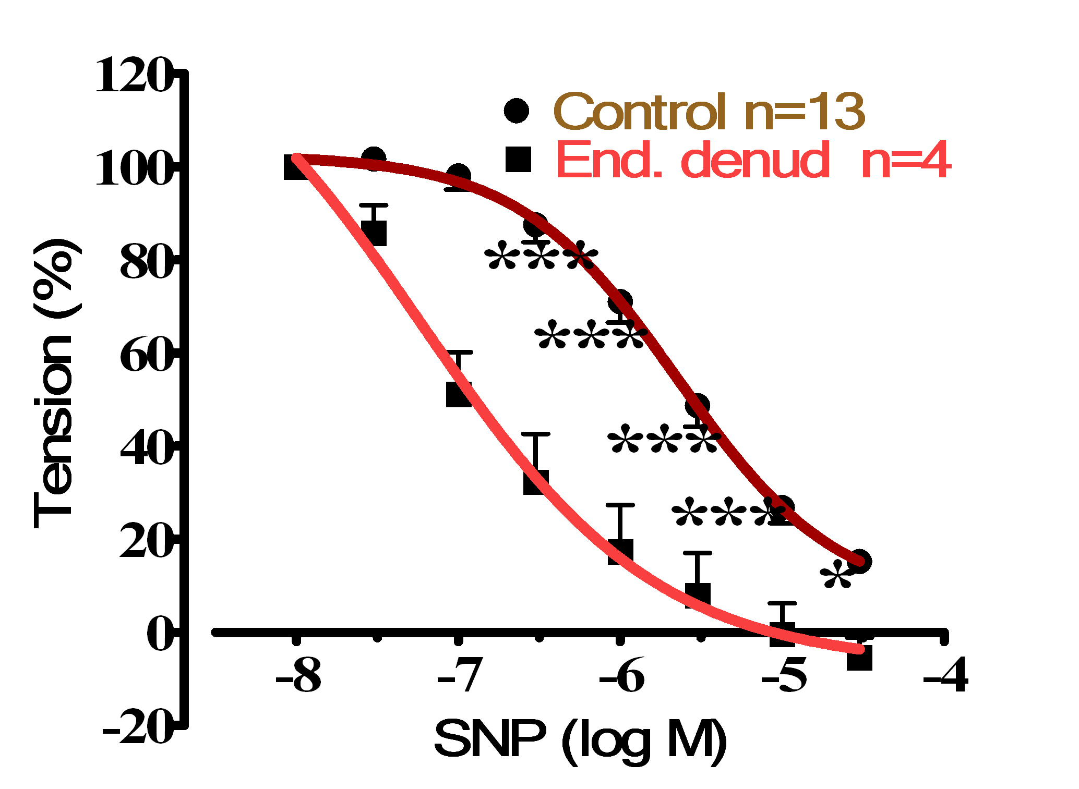

Figure 1. Cumulative dose-response curve for the vasorelaxant effects of SNP on control and endothelium denuded rat aortic rings, precontracted with PE (10–6 M).
The IC₅₀ (IC₅₀ of CI 95%) and E_{max} are shown in Table (1). Endothelium denudation significantly (P<0.001) induced relaxation at doses (3X10⁻⁷–1X10⁻⁵) and (P<0.05) at dose (3X10⁻⁵) for SNP with IC₅₀ 5.872X10⁻⁸ M (with IC₅₀ of CI 95% 4.149X10⁻⁹ to 8.309 X10⁻⁷), and 2.266X10⁻⁶ (with IC₅₀ of CI 95% 1.437X10⁻⁶ to 3.572X10⁻⁶) in the denuded and intact endothelial rings, respectively. The E_{max} for endothelium denuded and intact rings were 106.2±4.95% and 86.68±2.132%, respectively.
The IC₅₀, (IC₅₀ ofCI 95%) and E_{max} for the relaxant response to SNP following sustained contraction were significantly (P<0.001) higher in rings preincubated with Indomethacin and Clotrimazole than control rings (Figures ), with IC₅₀1.72X10⁻⁷ M (IC₅₀ ofCI 95% between 6.995 X10⁻⁸ to 4.231 X10⁻⁷) and 3.314 X10⁻⁸M (7.912 X10⁻¹¹ to 1.388 X10⁻⁵), and E_{max} were 121.5±5% and 121.1±8.09%, respectively. However, L-NAME and methylene blue pretreatments did not alter the dilation induced by SNP (Table 1).
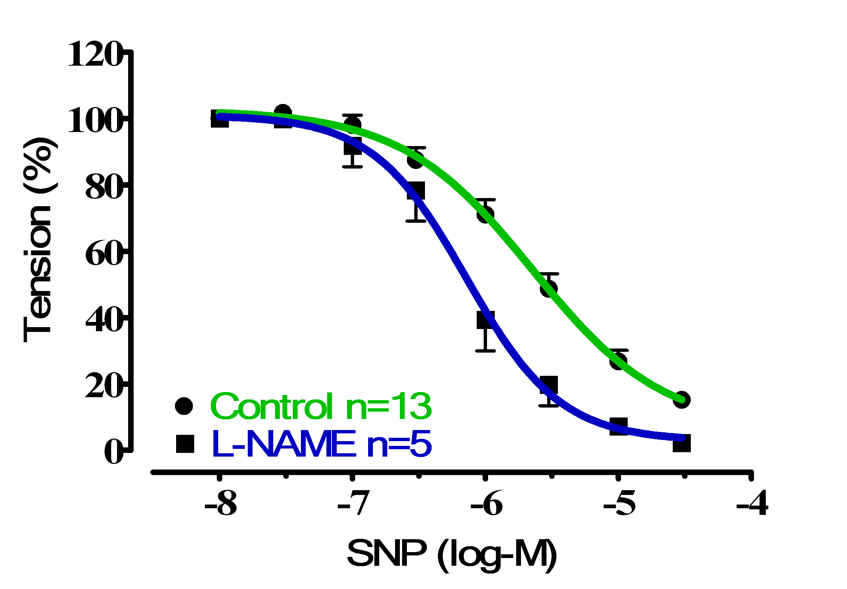Figure 2. Cumulative dose-response curve for the vasorelaxant effects of SNP on control and preincubated aortic rings with L-NAME (3X10⁻⁴ M), precontracted with PE (10^{–6} M)

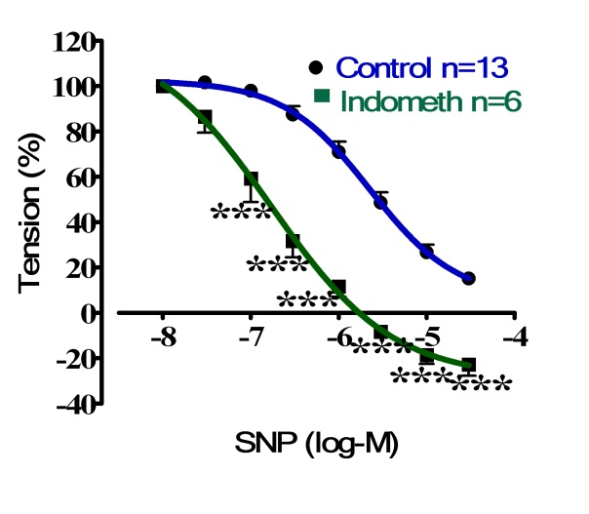
Figure 3.Cumulative dose-response curve for the vasorelaxant effects of SNP on control and preincubated aortic rings with Indomethacin (3X10⁻⁵M), precontracted with PE (10^{–6} M).
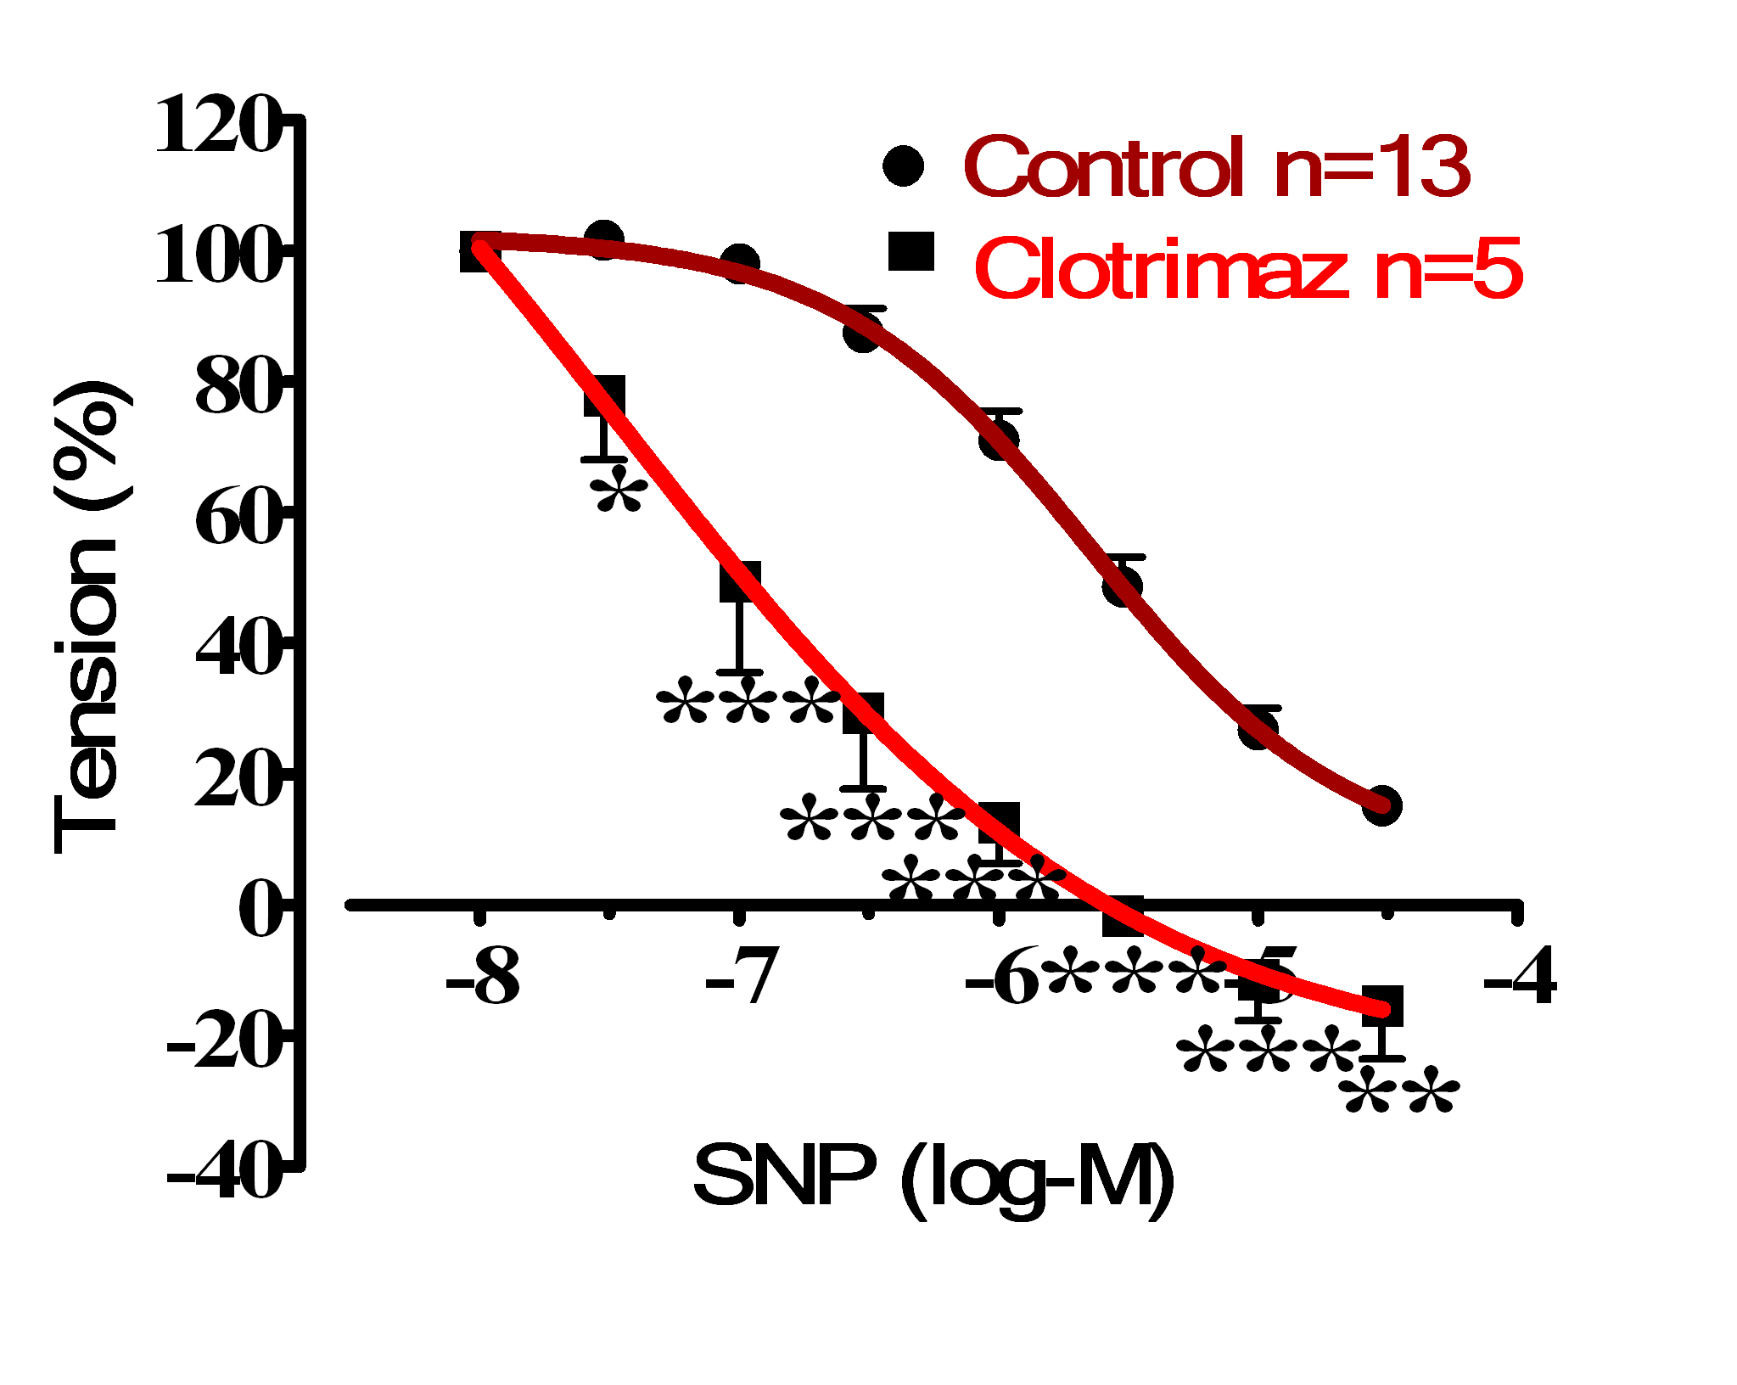

Figure 4.Cumulative dose-response curve for the vasorelaxant effects of SNP in control and preincubated aortic rings with Clotrimazole(3X10⁻⁵ M), precontracted with PE (10^{–6} M).
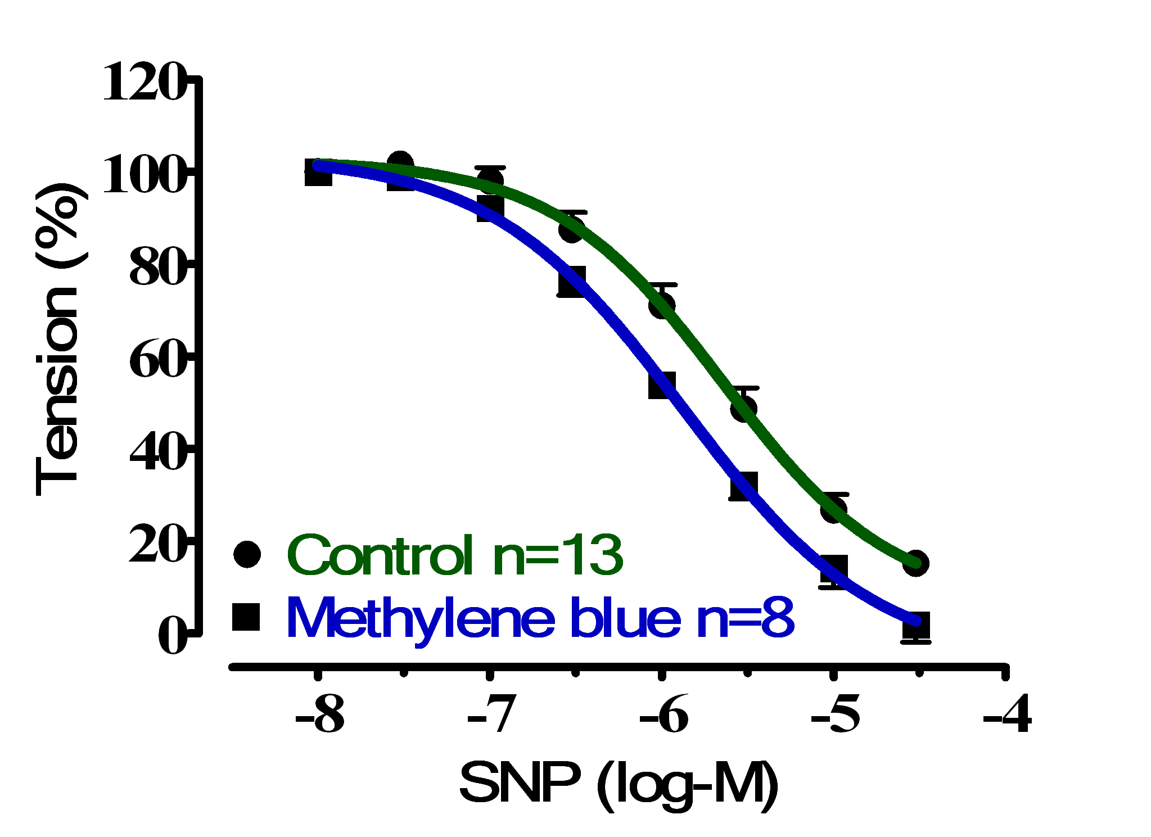
Figure 5. Cumulative dose-response curve for the vasorelaxant effects of SNPon control and preincubated aortic rings with methylene blue (3mM), precontracted with PE (10^{–6} M).

Table 1. The IC₅₀ (IC₅₀ of CI 95%) and E_{max} ± SEM for the effect of SNP on control and preincubated aortic rings with L-NAME, Indomethacin, Clotrimazole and methylene blue
Treatments | Control | Endothelium  Denudation | L-NAME  (3X10⁻⁴ M) | Indomethacin  (3X10⁻⁵ M) | Clotrimazole  (3X10⁻⁵ M) | Methylene blue (3mM)
IC₅₀ | 2.266X10⁻⁶ | 5.872X10⁻⁸ | 7.195X10⁻⁷ | 1.72X10⁻⁷ | 3.314X10⁻⁸ | 1.330 X10⁻⁶
95% CI  IC₅₀ | 1.437X10⁻⁶ to 3.572X10⁻⁶ | 4.149X10⁻⁹  to  8.309X10⁻⁷ | 4.878X10⁻⁷ to 1.061X10⁻⁶ | 6.995X10⁻⁸  to  4.231X10⁻⁷ | 7.912X10⁻¹¹  to  1.388X10⁻⁵ | 9.326X10⁻⁷  to  1.895X10⁻⁶
E_{max}± SEM | 86.68  ±2.132 | 106.2±  4.295 | 93.69  ±0.762 | 121.5  ±5 | 121.1  ±8.09 | 97.007±  3.79

DISCUSSION
It is well known that the endothelium plays an important role in the regulation of vascular tone by synthesis and release of endothelium-derived relaxing factors, including NO, PGI₂ and EDHF. Thus, it was decided to investigate role of endothelium and EDRFs involved in SNP-induced responses.
In the present study, endothelium removal enhanced the relaxant response to SNP, which may be attributed to the inhibitory effects of the factors released from endothelium. However, this endothelial factor not basal NO, because of L-NAME showed no influence on the relaxant effect of SNP in aortic rings. Although, Macdonald and his group (1989), concluded that endothelium releases ET-1 which abolishes the action of SNP, therefore by removing of endothelium SNP can further relax arteries.
Similar results were obtained to endothelial denudation in aortic rings pretreated with indomethacin or clotrimazole. These observations indicate that the releasing of PGI₂ and products of CYP₄₅₀ from intact endothelium blocks the action of SNP. However, Lugo et al., (1998) explained that prostaglandins may express an inhibitory action on NOS, and Khatsenkoet al., (1993) showed that overproduction of NO is involved in the suppression of CYP₄₅₀ activity by lipopolysaccharide. From these results, we can conclude that vasodilatory response of SNP will increase when aortic rings pretreated with either Indomethacin or Clotrimazole.
The results of the present study demonstrated that inhibition of basal NO and sGC had no effects on SNP-induced relaxation, indicating that endothelial derived NO and sGC do not appear to modulate this vasodilator response. These results along with previously described results explain that SNP directly activate different K⁺ channels.

REFERENCES
Adams, D J and Hill M A. 2004. Potassium channels and membrane potential in the modulation of intracellular calcium in vascular endothelial cells. J CardiovascElectrophysiol. 15(5):598-610.
Aziz, N; Malik H; Safur R; Samra B; Sidra R and Anwar H. 2009.Antihypertensive, antioxidant, antidyslipidemic and endothelial modulating activities of a polyherbal formulation (POL-10).Vascular Pharmacology. 50:57–64.
Dong, H; Gareth J; Denise G; William C and Christopher R. 1997.NO/PGI2-independent vasorelaxation and the cytochrome P450 pathway in rabbit carotid artery.Brit J Phar. 120, 695-701.
Hampl, V and Herget J. 2000.Role of nitric oxide in the pathogenesis of chronic pulmonary hypertension.Physiol. Rev. 80: 1337–1372.
Ignarro, L. 2010. Nitric oxide: Biology and pathobiology. Elsevier Inc.
Khatsenko, O; Gross O; Rifkind A and Vane J. 1993. Nitric oxide is a mediator of the decrease in cytochrome P450-dependent metabolism caused by immunostimulants. ProcNatlAcadSci U S A. 90 (23): 11147.
Lugo, B; Hernández D; Castillo C and Hong E. 1998. Prostaglandin and nitric oxide interactions in rat aorta. Proc West Pharmacol Soc. 41:91-2.
Luscher, T and Barton M. 1997.Biology of the endothelium.ClinCardiol. 20(II):3-10.
MacDonald, P;Kudo K; Dubbin P and Dusting G.1989. Rat aortic endothelium antagonizes nitroprusside-induced relaxation by release of the peptide endothelin. ClinExpPharmacol Physiol. 16(4):223-7.
Motulsky, H and Christopolous A. 2003.GrdaphPad Prism: Fitting models to biological data using linear and non-linear regression; A practical guide to curve fitting. GraphPad software, Inc.
Panza, J. 1997. Endothelial dysfunction in essential hypertension. ClinCardiol. 20(11 Suppl 2):II-26-33.
Shelkovnikov, S; Craig A and Harvey C. 2004. Influence of nitric oxide donors and peroxynitrite on the contractile effect and concentration of norepinephrine. Life Sciences.74; 2919–2928.
Si, J; Hui Z ; Yuqin Y; Zhi-Gen J and Alfred L. 2002. Nitric oxide induces hyperpolarization by opening ATP-sensitive K‏ channels in guinea pig spiral modiolar artery. Hearing Research. 171;167-176.
Ying, W and Sanders P. 2002. Increased dietary salt activates rat aortic endothelium. Hypertension. 39(2):239-44.
Zhang, D. 2007. Hydroperoxide-induced Oxidative Stress in the Arterial Wall: Pharmacological Characterization of the Effects on Arterial Contractility. Academic thesis: EberhardKarlsUniversitätTübingen

رؤلَى رِووثؤسة شانة و فاكتةرة خاوبووةكانى رِووثؤسة شانةوة دةردةضن لة خاوبوونةوةى شاخويَنبةرى دروست بوو بةNO
ثوختة
رِووثؤسة شانة دةوريَكى سةرةكى لةكؤنترؤل كردنى خويَنبةرةكان دةبيَت. بؤية, ئامانجى ئةم تويَذينةوةية بريتيية لة دياري كردنى رؤلى رِووثؤسة شانة و فاكتةرة خاوبووةكانى لة رِووثؤسة شانةوة دةردةضن لة خاوبوونةوةى سينطة شاخويَنبةر, وةك وةلآمدانةوةى بةخشةرى NOكة بريتيية لةSNP بةبةكارهيَنانى سيستةمى PowerLab. لابردنى رِووثؤسة شانةى شاخويَنبةر, بوة هؤى هاندانى وةلآمدانةوةى خاوبونةوة بؤ SNP (1X10⁻⁸بؤ3X10⁻⁵) و بة ثةيتى بةكارى5.872X10⁻⁸مؤلَ لة2.266X10⁻⁶ مؤلَةوة بؤ كؤنترؤل, سةرةرِاى ئةوة رِيَذةى سةدى خاوبوونةوة بؤ ئةو طويَزةرةوة طازيية بريتي بوو لة 106.2±4.95% و بةبةراورد لةطةل كؤنترؤل86.68±2.132%.وةلآمدانةوةى خاوبونةوة بؤ SNP لة ئةلقةكانى شاخويَنبةر بة شيَوةيةكى بةرضاو زيادى كرد بة ثيَشةكى ئالَوويَركردن بة Indomethacin و Clotrimazoleبة ثةيتى بةكارى 1.72X10⁻⁷ مؤلَ و 3.314 X10⁻⁸ مؤلَ و رِيَذةى سةدى خاوبوونةوة زيادى كرد بؤ 121.5±5% و 121.1±8.09%, يةك لةدواى يةك. لة كاتيَكدا, هيض طؤرانكارييةك روينةدا لةو شاخويَنبةرةى كة بة ثيَشةكى ئالَوويَركرا بوو بة L-NAME و مةسيلينى شين. ئةم ئةنجامانة ئةوة دةردةخةن كة لابردنى رِووثؤسة شانة و بلؤك كردنى فاكتةرة خاوبووةكانى لة رِووثؤسة شانةوة دةردةضن هانى خاوبوونةوة دا كة بةهؤي NOةوة دروست دةبيَت;ئةمةش رِؤلَىرِووثؤسة شانة دةردةخات لة كاريطةرى خاوبوونةوةي NO.

دور الأندوثيليم وEDRFs في استجابة الأسترخاء الابهر لNO
الملخص
ان الأندوثيليم يلعب دوراً رئيسياَ في الأسترخاء الابهر. لذلك, الهدف من هذه التجربة هي تحديد دور الأندوثيليم وEDRFs في الأسترخاء الابهر استجابة لواهب NO (SNP) باستخدام جهاز PowerLab. ان تجريد الأندوثيليم ادت الى تحفيز استجابة التركيز SNPمع التركيز الفعال 5.872X10⁻⁸مولو2.266X10⁻⁶, مع ذلك نسبة الأسترخاء 106.2±4.95% و 86.68±2.132% مقارنة مع الكونترول, على التوالي.ان الأسترخاء المستحدث ب SNPفي الحلقات الأبهر تعززت معنوياً بواسطةIndomethacin و Clotrimazoleعند التركيز الفعال 1.72X10⁻⁷ مول و 3.314 X10⁻⁸ مول و ان نسبة الأسترخاء ازدادت الى 121.5±5% و 121.1±8.09%, على التوالي. في حين,لم يحصل اي تغيير في الأسترخاء المستحدث ب SNPفي الحلقات الأبهر بواسطة المعاملة المسبقة بكل من L-NAME و مثيلين الازرق. استنجت النتائج بأن ان تجريد الأندوثيليم و تثبيط EDRFs ادت الى تحفيز استجابة الأسترخاء الابهر لNO و يوضح دور الأندوثيليم في استجابة الأسترخاء الابهر ل.NO

