GUIDELINES FOR AUTHORS PREPARING MANUSCRIPTS FOR PUBLICATION IN THE SCIENCE JOURNAL OF UNIVERSITY OF ZAKHO (SJUOZ)

Yaseen T. Mustafa a,[1]*, Karwan F. Jacksi a, Alfred H. Partick b, Karlee X. Sam c

a Faculty of Science, University of Zakho, Zakho, Kurdistan Region, Iraq - (yaseen.mustafa, karwan.jacksi)@uoz.edu.krd

b Faculty of Science and Technology, University of Twente, Enschede, The Netherlands - patrick@utwente.nl

c Information Technology Research and Development, Eastern Mediterranean University, Famagusta, TRNC, Cyprus -sam@emu.edu.tr

***Received: xxx / Accepted: xxx / Published: xxx***

ABSTRACT:

These guidelines are provided for preparation of papers accepted for publication in the Science Journal of University of Zakho (SJUOZ). These guidelines are issued to ensure a uniform style. All papers that are accepted in SJUOZ will be published provided they arrive by the due date and they correspond to these guidelines. Reproduction is made directly from author-prepared manuscripts electronically in A4 paper size 21 cm x 29.7 cm. To assure timely and efficient production of the SJUOZ, authors must submit their manuscripts in strict conformance with these guidelines. The Editorial board may omit any paper that does not conform to the specified requirements. *There will be no opportunity for corrections or improvements of poorly prepared originals.*

**KEYWORDS:** Manuscripts, Science, Journal of University of Zakho, University of Zakho, Guidelines for Authors, Template.

# MANUSCRIPT

## Instructions

The maximum paper length is restricted to 12 pages. The manuscript should have the following structure:

1. Paper Title
2. Authors and affiliation
3. Keywords (minimum 5 words)
4. Abstract (100 – 200 words)
5. Introduction
6. Main body
7. Conclusions
8. Acknowledgements (optional)
9. References
10. Appendix (optional)

Full papers submitted for double-blind review to the SJUOZ must not contain any information which makes it possible to identify the authors. In particular, names and affiliations must be removed from the manuscript submitted for review. Therefore, submissions which have not been appropriately anonymised may be subject to immediate rejection.

## Page Layout, Spacing and Margins

Title and Abstract of the paper must be compiled in one column and all subsequent text (rest of the paper) must compiled in two columns. All text should be single-spaced. Left and right justified typing is needed.

## Preparation in electronic form

This digital version of the styleguide is to assist authors in preparing their papers. Currently, it is provided in Word only. For the near future SJUOZ will provide a digital version of the styleguide in LaTeX. These digital versions are available on on the SJUOZ web Page, see. <http://sjuoz.uoz.edu.krd/index.php/sci/about/submissions>.

## Length and Font

All manuscripts are limited to a size of no more than twelve (12) single-spaced pages (A4 size), including abstracts, figures, tables and references. The font type Times New Roman with a size of nine (9) points is to be used.

Table 1. Margin settings for A4 size paper

|  |  |  |
| --- | --- | --- |
| Setting | A4 size paper | |
| mm | inches |
| Top | 25 | 1.0 |
| Bottom | 25 | 1.0 |
| Left | 20 | 0.8 |
| Right | 20 | 0.8 |
| Column Width | 82 | 3.2 |
| Column Spacing | 6 | 0.25 |

# TITLE AND ABSTRACT BLOCK

## Title

The title should appear centered in bold capital letters, at the top of the first page of the paper with a size of twelve (12) points and single-spacing. After one blank line, type the author(s) name(s), affiliation and mailing address (including e-mail) in upper and lower case letters, centred under the title. In the case of multi-authorship, group them by firm or organization as shown in the title of these Guidelines.

## Abstract

Leave one lines blank, then Type "**ABSTRACT:**" flush left in bold Capitals. Start now with a concise Abstract (100 - 200 words) which presents briefly the content and very importantly, the news and results of the paper in words such to be understandable also to non-specialists.

## Key Words

Leave one lines blank, then type "**KEYWORDS:**" in bold capital letters, followed by minimum of 5 key words. Those key words are used to find a paper with content you are preparing.

# MAIN BODY OF TEXT

Type text single-spaced, with one blank line between paragraphs and following headings. Start paragraphs flush with left margin.

## Headings

Major headings are to be centered, in bold capitals without underlining, after two blank lines and followed by a one blank line.

Type subheadings flush with the left margin in bold upper case and lower case letters. Subheadings are on a separate line between two single blank lines.

Subsubheadings are to be typed in bold upper case and lower case letters after one blank line flush with the left margin of the page. The text of the subsubheadings must be followed on the same line. Subsubheadings may be followed by a colon (**:**), they may also be the first word of the paragraph's sentence.

Use decimal numbering for headings and subheadings

## Footnotes

Mark footnotes in the text with a number (1); use the same number for a second footnote of the paper and so on. Place footnotes at the bottom of the page, separated from the text above it by a horizontal line.

## Illustrations and Tables

### **Location:** Figures must be placed in the appropriate location in the document, as close as practicable to the reference of the figure in the text. While figures and tables are usually aligned horizontally on the page, large figures and tables sometimes need to be turned on their sides. If you must turn a figure or table sideways. Note that the top is always on the left-hand side of the page.

### **Captions**: All captions should be typed in upper and lower case letters, centered. For tables the captions has to be directly above the table. While, the caption of the Figure must be directly beneath the figure. Use single spacing if they use more than one line. All captions are to be numbered consecutively, e.g. Figure 1, Table 2, Figure 3.

### **Copyright**: If your article contains any copyrighted illustrations or imagery, please include a statement of copyright such as: © company name or the book title Copyright 20xx (fill in year). It is the author's responsibility to obtain any necessary copyright permission. After publication, your article is distributed under the [Creative Commons Attribution 4.0 License](http://creativecommons.org/licenses/by/3.0/) and you retain the copyright.

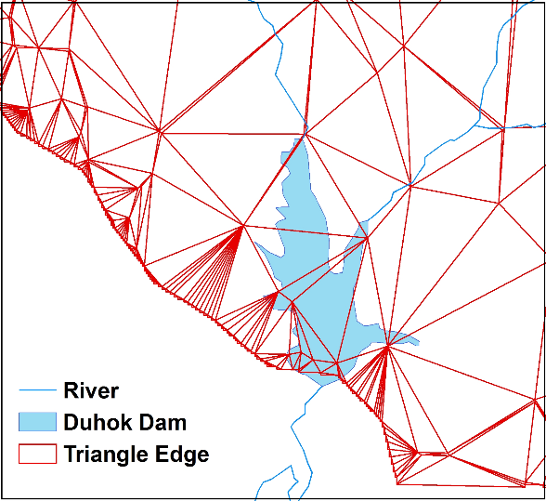

Figure 1. Figure placement and numbering

## Equations, Symbols and Units

### **Equations**: Equations should be numbered consecutively throughout the paper. The equation number is enclosed in parentheses and placed flush right. Leave one blank lines before and after equations:

$$x=x_{0}-c\frac{X-X_{0}}{Z-Z_{0}}; y=y_{0}-c\frac{Y-Y_{0}}{Z-Z_{0}} (1)$$

where *c* = constant

*x*, *y* = target coordinates

*X0*, *Y0*, *Z0* = initial coordinates

*X*, *Y*, *Z* = object coordinates

### **Symbols and Units**: Use the Système International Units and Symbols ([SI](https://en.wikipedia.org/wiki/International_System_of_Units)). Unusual characters or symbols should be explained in a list of nomenclature.

## References

References should be indicated in the typescript by giving the author's name, with the year of publication in parentheses, as detailed in the APA style guide. For example thus (Mustafa, 2013), and listed in alphabetical order in the reference section in standard APA format. The following arrangements should be used:

### **References from Journals:** Journals should be cited like (Mustafa, 2014). Names of journals can be abbreviated according to the "International List of Periodical Title Word Abbreviations". In case of doubt, write names in full.

### **References from Books:** Books should be cited like (Ceder, 2014).

### **References from Conference:** conferences should be cited like (Ardila, Bijker, Tolpekin, & Stein, 2012).

### **References from Other Literature:** Other literature should be cited like (Smith, 2000).

### **References from websites:** References from the internet should be cited like (Digital Globe, 2009).

# Acknowledgements (optional)

Acknowledgements of support for the project/paper/author are welcome.

# References

Ardila, J., Bijker, W., Tolpekin, V., & Stein, A. (2012). *Gaussian localized active contours for multitemporal analysis of urban tree crowns*. Paper presented at the 2012 IEEE International Geoscience and Remote Sensing Symposium.

Ceder, A. (2014). *Public Transit Planning and Operation: Theory, Modeling and Practice*, Second Edition: Taylor & Francis Group.

Digital Globe. (2009). The benefits of the 8 spectral bands of WorldView-2. Retrieved January 13, 2014, from <http://www.satimagingcorp.com/media/pdf/WorldView-2_8-Band_Applications_Whitepaper.pdf>

Mustafa, Y. T. (2013). Satellite Remote Sensing for Spatio-Temporal Estimation of Leaf Area Index in Heterogeneous Forests. *International Journal of Environmental Protection*, 3(4), 10-16.

Mustafa, Y. T., Tolpekin, V. A., & Stein, A. (2014). Improvement of Spatio-temporal Growth Estimates in Heterogeneous Forests Using Gaussian Bayesian Networks. *IEEE Transactions on Geoscience and Remote Sensing*, , 52(8), 4980-4991.

Smith, J. (2000). Remote sensing to predict volcano outbursts. *The International Archives of the Photogrammetry, Remote Sensing and Spatial Information Sciences*, 456-469.

# Appendix (optional)

Any additional supporting data may be appended, provided the paper does not exceed the limits given above.

*Revised April 2017*

1. * Corresponding author